Warm-Up Exercise #6
Get down on the floor on your hands and Knees with your hands positioned under your shoulders and your knees under your hips. Bring your chin up and rotate your hips so the tailbone moves up, arching your back down. Then tuck your chin into your chest and rotate your back so that your pelvis moves down, arching you're your back down.  Breathing: Inhale as you move your tailbone up and exhale as you move your tailbone down. | 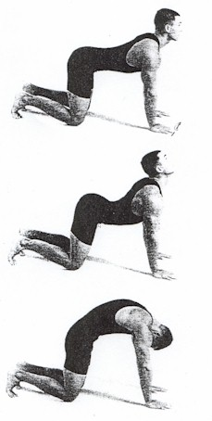

Conclusion: The daily practice of the exercises I have described in this article is an essential element of vibrant health. It's a proven fact that people who loose weight can only maintain their weight loss if they incorporate a daily exercise program into their everyday lives.
These exercises will stretch muscles you haven't felt in years so approach this program gently and begin with one or two repetitions each day, increasing each exercise by one repetition every week. After you are able to do ten repetitions of the Alternate Exercise program, you should be able to begin to do the Five Rites.
And add a half hour of a brisk walk on a daily basis. Not only will it contribute to your physical health, it will give you the opportunity to enjoy all of nature around you. You will feel younger than you have felt in years.
Happy and Joyous Vibrant Health

With Love and Caring,
Mary Kurus
mary@mkprojects.com
www.mkprojects.com
Copyright 2001 Mary Kurus All Rights Reserved

Five Yoga Exercises for a very healthy back,

The Ancient Secret of the Fountain of Youth

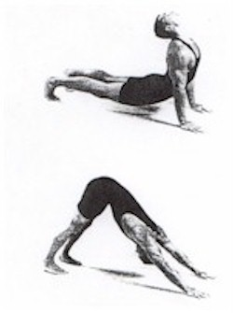

The Five Tibetan Rites: Exercises for Healing, Rejuvenation, and Longevity
By Mary Kurus
Copyright Mary Kurus 2001, All Rights Reserved

Background
In 1985 a book called The Ancient Secret of the Fountain of Youth written by Peter Kelder was published which for the first time fully described an exercise program for "youthing". This is an exercise program used by Tibetan monks to live long, vibrant and healthy lives. In fact, this book states that many have lived longer than most can imagine by following the program often called the "Five Tibetan Rites". The benefits are described in this book and a subsequent book 2 with an expanded description of the program by the publisher called the Ancient Secret of the Fountain of Youth - Book 2, a companion to the original book by Peter Kelder. Many thanks to the publisher Doubleday for such a special an expanded explanation of the Five Rites.

Potential Benefits of the Five Rites
The authors provide many examples of the benefits of the "Five Tibetan Rites" including the following: looking much younger; sleeping soundly; waking up feeling refreshed and energetic; release from serious medical problems including difficulties with spines; relief from problems with joints; release from pain; better memory; arthritis relief; weight loss; improved vision; youthing instead of aging; greatly improved physical strength, endurance and vigor; improved emotional and mental health; enhanced sense of well being and harmony; and very high overall energy.

How the Five Rites Work
Medical professions explain the benefits based on their personal perspective and I suggest you read the entire two books for a broad overview. However, the majority share the view that the rites represent a system of exercise that affects the body, emotions and mind. The Tibetans claim that these exercises activate and stimulate the seven key chakras that in turn stimulate all the glands of the endocrine system. The endocrine system is responsible for the body's overall functioning and aging process. This means that the Five Rites will affect the functioning of all your organs and systems, including the physical and energetic systems and that includes the aging process. The man who brought these Five Rights out of Tibet stated that "performing the Five Rites stimulates the circulation of essential life energy throughout the body".

Chakras
Chakra is an Indian Sanskrit word that translates to mean "Wheel of Spinning Energy". Chakras are spinning wheels or vortexes of energy of different color that perform many functions connecting our energy fields, bodies and the Cosmic Energy Field. Chakras are powerful electrical and magnetic fields. Chakras govern the endocrine system that in turn regulates all of the body's functions including the ageing process. Energy flows from the Universal Energy Field through the chakras into the energy systems within our bodies, including the Meridian System.
Our bodies contain seven major chakras or energy centers and 122 minor chakras. The major chakras are located at the base of the spine (Root Chakra), at the navel (Sacral Chakra), in the solar plexus (Solar Plexus Chakra), within your heart (Heart Chakra), within the throat (Throat Chakra), at the center of your forehead (Brow or Third Eye Chakra), and at the top of your head (Crown Chakra). These chakras are linked together with all other energy systems in the body and various layers of the auras.
The Speed of the chakra spin is a key to vibrant health. The other keys to vibrant health that relates to the chakra is ensuring they are clear of negative energy and that they are perfectly shaped and not distorted.

Warm-Up Exercise #3
Stand upright with your arms help up, your elbows bent, and your hands together in front of your chest, with your fingertips touching and palms apart. Press inward on your fingers until their inside surfaces are almost touching. Your palms should not be touching. Release and press your fingers again.  Breathing: Breathe normally. | 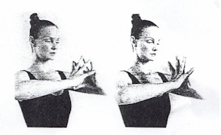

Warm-Up Exercise #4
In a relaxed standing position, hold your arms in front of you. Clasp your right hand around your left wrist, with your thumb against the inside of the wrist. Squeeze gently but firmly five times. Repeat the procedure with the left hand Squeezing the right wrist.  Breathing: Breathe normally. | 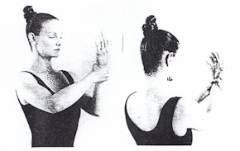

Warm-Up Exercise #5
Recline on the floor, resting the upper part of your body on your upper arms. Flex your knees and rhythmically bang Them up and down against the floor in rapid succession. Your heels should remain on the floor throughout this exercise. Do this exercise for 20 - 30 seconds.  Breathing: Breathe normally through this exercise. | 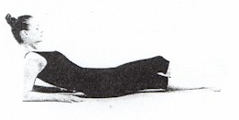

Warm-up Exercises
The following group of exercises has been developed to open, relax, release tension, to strengthen various parts of the body, and to provide toning to different parts of your body.
If you are overweight, in poor physical condition, or experiencing serious illness, this group of exercises is an excellent to help you begin your journey towards physical fitness. I suggest you do these warm-up exercises prior to the Five Rites if you are overweight or have not exercised in a long time.
Begin this group of exercises by doing 2 of each exercise and then gradually increase the repetition until you are able to do 10 of each warm-up exercise.

Warm-Up Exercise #1
Stand upright, tilt your head sideways towards your left shoulder and hold it for five seconds, then tilt your head towards your chest and hold it 5 seconds. Then tilt your head towards your left Shoulder and hold it five seconds, and lastly tilt your head backward and hold it five seconds. Return your head to a normal position.  Breathing: Exhale as you move your head around, and inhale as you return to the upright position. | 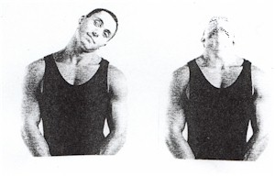

Warm-Up Exercise #2
Stand upright, slowly rotate your shoulders in a forward circular motion 5 times, then reverse the movement and rotate your shoulders in a backward circular motion 5 times.  Breathing: Breathe normally but deeply as you do this exercise. | 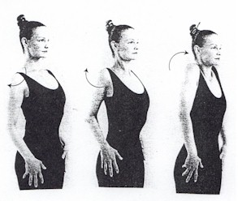

The Five Rites speed up the spinning of the chakras, coordinate their spin so they are in complete harmony, distribute pure prana energy to the endocrine system, and in turn to all organs and processes in the body. This is one of the major requirements for vibrant health, rejuvenation and youthfulness.

The Five Rites Exercise Program
This program is often described as a modified yoga program. Simply put, yoga is a science that unites the body, mind and spirit. Today this is often called Mind/ Body Healing. The author of the book believes that yoga was brought to Tibet from India in the 11th or 12th century and that Tibetan monks over time developed modified these exercises and developed an effective program of exercises that western society now calls the "Five Tibetan Rites". The rugged mountainous conditions these monks live in may well account for their particular emphasis on vigor. Many of the yoga exercises and practices being taught in the western world today are very new. The "Five Tibetan Rites" are exactly what the ancient Tibetans developed over many centuries of time. Therefore it's very important to do the "Five Tibetan Rites" exactly as they are presented without altering the form or sequence to achieve some of the benefits accrued to these "Rites".

Beginning the "Five Rites" Exercise Program
- For the first week, and only if your are relatively healthy and fit, do each exercise three times.
- If you are inactive, overweight, or have health problems begin these exercises doing one of the first three each day, and only if you feel totally comfortable doing this. Later in this article I will describe exercises you can do to help yourself strengthen so you can begin to do the "Five Rites". If you have any concerns whatsoever, please consult with your physician. Individuals on serious medications should consult with their physicians.
- If you are overweight do not do Rites #4 and #5 until you have developed some strength and endurance. Do the substitutes for #4 and #5 until you yourself feel ready to begin doing #4 and #5 of the "Five Rites".
- Do only what you feel comfortable doing. That may be only one of each exercise for the first week. Build up to two of each exercise the second week, three of each exercise the third week, etc. or at a faster pace only if your body does not hurt when you do these exercises.
- 21 is the maximum of each exercise you should ever do. If you want to enhance your program, do the exercises at a faster pace, but do not so more than 21 of each exercise each day. Doing more than 21 repetitions of each exercise in any day will affect your chakras negatively and can create imbalances in your body.
- The "Five Rites" may stimulate detoxification and often creates many unpleasant physical symptoms. This is why it's recommended to increase the number of each exercise gradually on a weekly basis. I also recommend a vibrational detoxification with Choming Essences. For more information on vibrational detoxification with Choming Essences please visit my website www.mkprojects.com.
- If you have not exercised for some time, prepare to begin your "Five Rites" exercise program by walking daily, for a half hour each day if possible. Another alternative in preparation for the Five Rites is a stretching program with a gradual increase in the types of stretching exercises and the duration of this program.
- A sugar free and low fat diet is an important support when integrating the "Five Rites" exercise program into your life. Also check for Digestive Food Sensitivities and eliminate all foods you do not digest easily.
- Do the Five Rites exercises every day. The maximum you should skip is one day each week. If the exercises are done less than six days each week, the results will be greatly reduced.
- If on certain days your time is limited, do 3 repetitions of each exercise. This takes less than five minutes.
- For maximum benefit, do the exercises before breakfast in the morning, if at all possible. If this is not possible do them anytime during the day.

Detoxification
Detoxification is a process that helps to clean out of the physical and energetic body toxins or poisons that have accumulated in your physical cells, organs, systems and in your energetic systems (auras, chakras, meridian system and all electromagnetic, magnetic and electric systems). I strongly recommend that people beginning the "Five Rites" exercise program undertake a Choming Essence detoxification program either before or as they begin these exercises.
If you have never detoxified you will probably have many poisons accumulated in your body and energetic systems. A full detoxification program with Choming Flower Essence, Gem Essences, and Tree Essences will eliminate all toxins. Detoxifying with Choming Essences uses vibrational essences, or what is sometimes called vibrational medicine to clear your systems of toxins and poisons. This includes the elimination of parasites, candida, viruses, and all poisons from pollution, pesticides etc.
This vibrational approach to detoxification is completely complementary to the exercises of the "Five Rites". Detoxification is essential for vibrant and long life. For more information please refer to my article "Detoxification with Choming Essences" and other vibrational health articles on my website at www.mkprojects.com.

"Five Tibetan Rites" Exercise Program
The following instructions and photographs for the "Five Rites" and other preparatory exercises as taken from the book Ancient Secret of the Fountain of Youth, Book 2. I will show the exact Five Rights exercises, a group of exercises for those who need to develop flexibility and strength before beginning to do the "Five Rites", and a set of warm-up exercises. I strongly recommend you purchase the book since it provides detailed information about methodology, concerns and benefits not included in this article.
SPECIAL CAUTION: Spinning and stretching through the following exercises can aggravate certain health conditions such as any type of heart problem, multiple sclerosis, Parkinsons's Disease, severe arthritis of the spine, uncontrolled high blood pressure, a hyperthyroid condition, or vertigo. Problems may also be caused if you are taking drugs that cause dizziness. Please consult your physician prior to beginning these exercises if you have any difficult health issues or if you have any other concerns.

The Five Tibetan Rites

Rite #1
Stand erect with arms outstretched horizontal to the floor, palms facing down. Your arms should be in line with your shoulders. Spin around clockwise until you become slightly dizzy. Gradually increase number of spins from 1 spin to 21 spins.  Breathing: Inhale and exhale deeply as you do the spins. | 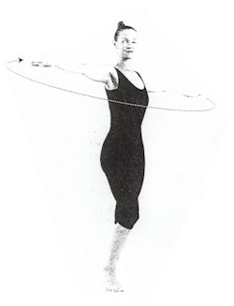

Alternative ( for Rite #4) Exercise #4
Lie flat on your back, your arms straight, palms down, feet flat, and knees bent. Press your pelvis up a few inches off the floor and hold it for 10 seconds. Release and lower your pelvis to its original position.  Breathing: Inhale as you lift your pelvis and Exhale as you lower your pelvis. | 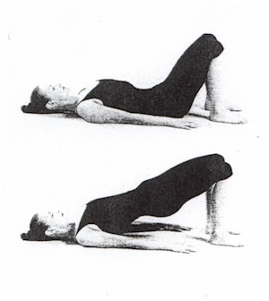

Alternative ( for Rite #5) Exercise #5
Begin in the table position. Curl your toes under And bend your hips raising your buttocks so that Your body forms an inverted "V". Your knees will lift up off the floor, your legs will be straight, and your outstretched arms will be in a straight line with your back. Hold this position for 15 seconds.  Breathing: Inhale as you raise your buttocks, breath Slowly and deeply while holding the position, and exhale as you return to the table position. | 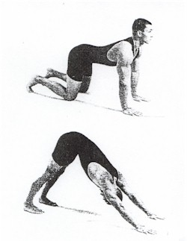

Alternative (for Rite #2) Exercise #2
Lie down on the floor and elevate your head and shoulders propping up on your elbows keeping your forearms flat on the floor, palms facing down. Keeping your legs straight, hold them off the floor For 20 or 30 seconds.  Breathing: Inhale as you raise your legs, breathe in and out normally while holding your legs up, and exhale as you lower your legs. | 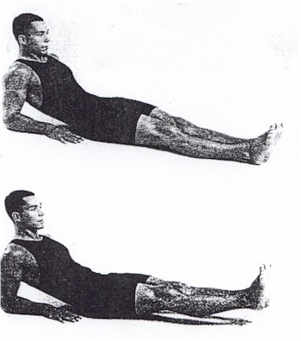

Alternative ( for Rite #3) Exercise #3
Stand with your back to the wall and your feet 12 - 18 inches apart. Without moving your feet bend forward from the hips so that your buttocks rest against the wall. Slide downward, bending your knees as you go. Keep sliding down until your thighs are horizontal, as if you were sitting in a chair. Hold this position for 15 seconds and then slide back up.
Breathing: Begin to exhale as you slide down to the chair position and inhale when slide back up.

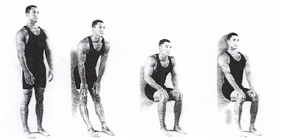

Rite #2
Lie flat on the floor, face up. Fully extend your arms Along your sides and place the palms of your hands against the floor, keeping fingers close together. Then raise your head off the floor tucking your chin into your chest. As you do this, lift your legs, knees straight, into a vertical position. If possible, extend the legs over the body towards your head. Do not let the knees bend. Then slowly lower the legs and head to the floor, always Keeping the knees straight. Allow the muscles to relax, and repeat.  Breathing: Breathe in deeply as you lift your head and legs and exhale as you lower your head and legs. | 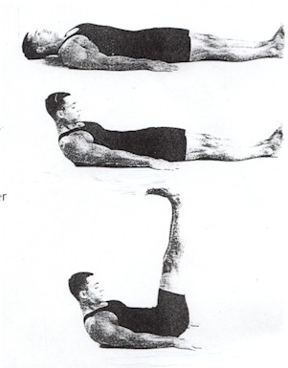

Rite #3
Kneel on the floor with the body erect. The hands should be placed on the backs of your thigh muscles. Incline the head and neck forward, tucking your chin in against your chest. Then throw the head and neck backward, arching the spine. Your toes should be curled under through this exercise. As you arch, you will brace your arms and hands against the thighs for support. After the arching return your body to an erect position and begin the rite all over again.  Breathing: Inhale as you arch the spine and exhale as you return to an erect position. | 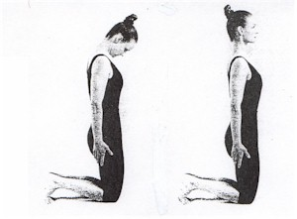  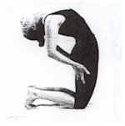

Rite #4
Sit down on the floor with your legs straight out in front of you and your feet about 12" apart. With the trunk of the body erect, place the palms of your hands on the floor alongside your buttocks. Then tuck the chin forward against the chest. Now drop the head backward as far as it will go. At the same time raise your body so that the knees bend while the arms remain straight. Then tense every muscle in your body. Finally let the muscles relax as you return to your original sitting position. Rest before repeating this Rite.  Breathing: Breathe in as you raise up, hold your breath as you tense the muscles, and breathe out fully as you come down. | 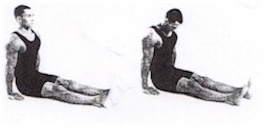  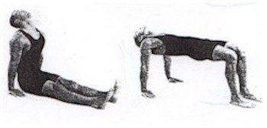

Rite #5
Lie down with your face down to the floor. You will be supported by the hands palms down against the floor and the toes in the flexed position. Throughout this rite, the hands and feet should be kept straight. Start with your arms perpendicular to the Floor, and the spine arched, so that the body Is in a sagging position. Now throw the head back as far as possible. The, bending at the hips, bring the body up into an inverted "V". At the same time, bring the chin forward, Tucking it against the chest.
Breathing: Breathe in deeply as you raise the body, and exhale fully as you lower the body.

Exercises In Preparation For Doing the Five Tibetan Rites
The following group of exercises has been developed as a preparation for doing the Five Rites, or as an alternative when you are unable to do any of the Five Rites. Doing these exercises will help you strengthen and become more flexible to be able to do the Five Rites as they have been described above.
Do these alternative exercises in the sequence from one to five and when possible, substitute the Five Rite exercise into this alternative program until you have fully integrated the Five Rites.
As with the Five Rites, begin by doing two or three of each exercise daily, until you are able to do 10 each day. Once you are able to do ten of these alternatives, you should be ready to begin doing the Five Rite exercises themselves.

Alternative (for Rite#1) Exercise #1
Stand with your feet about 12 inches apart. Extend your arms palms down until your arms are level with your shoulders. Swing your arms to the right, letting your slapping your left hand against your right shoulder, with your right hand slapping against the small of your back. Then swing your arms in the opposite direction, having your right hand slap against your left shoulder and the back of your left hand slap against the small of your back. As you swing back and forth allow your torso and legs to follow the movement. Allow your heels to lift from the floor but do not allow either foot to completely leave the floor. As you swing right turn your head right, and turn your head left as you swing to the left.  Breathing: Breathe in rhythm to your swinging Movement. | 